# C3- S8 PRACTICE

# Flowchart to Boolean expression

Example

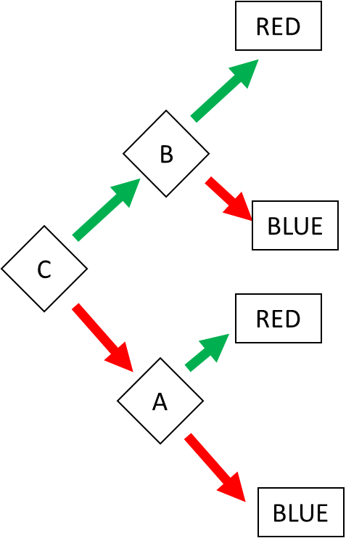

Answer:

RED = (C and B) or (!C and A)

BLUE = (C and !B) or (!C and !A)

# Ex 1: Find the Boolean expression of BLUE

BLUE = (AB!C) or (A!B) or (!A!DB)

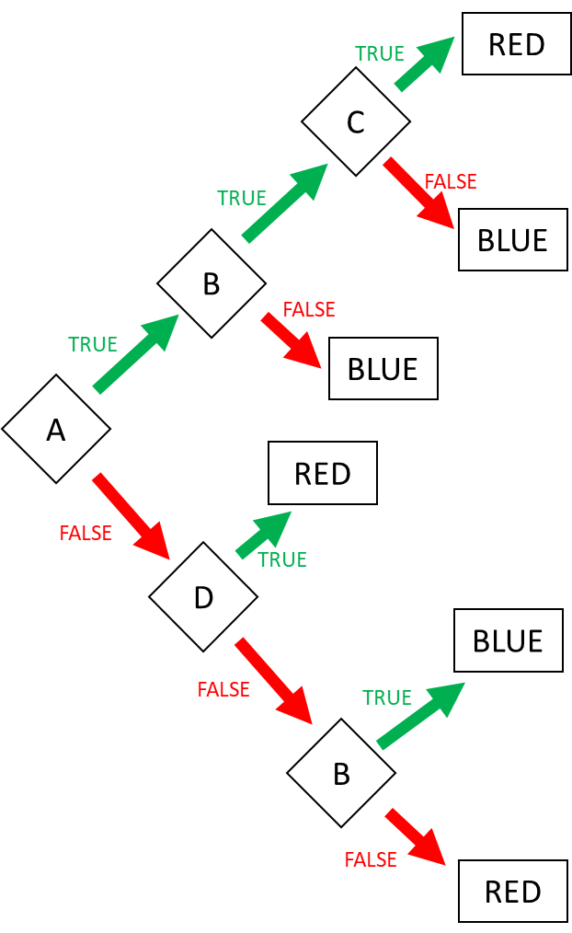

# Ex 2: Find the Boolean expression of BLUE

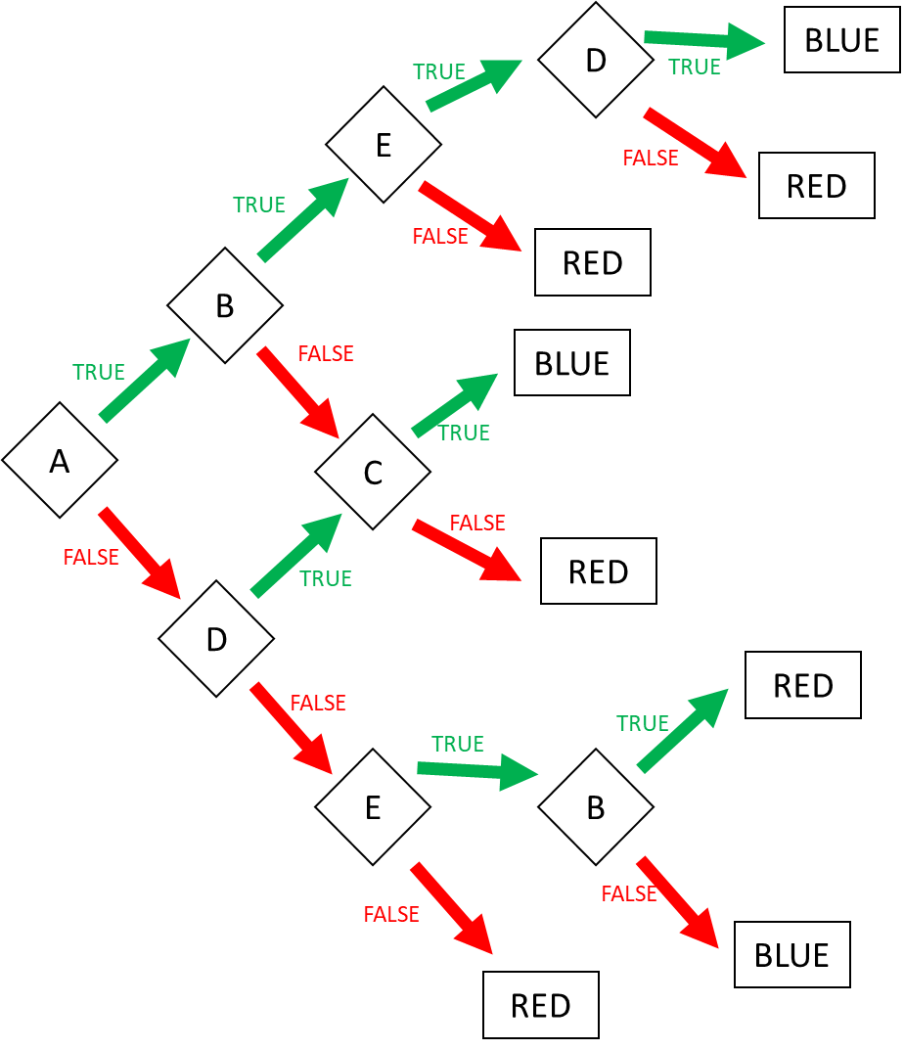

BLUE = (ABED) or (A!BC) or (!ADC) or (!A!DE!B)

Ex 2: Create the flowchart according to the expressions (4 flowcharts):

1. Go to the market = AB or !A!C
2. Go to swim = ( Sunny AND Sunday) OR ( !(Sunny) and Monday and no homework)
3. I’m superman = A!BCD or AB!CD or !ABCD
4. Happy = ABC!DE!F or A!BCD!EF or !ABCD!E or !A!BC

1 Go to market: AB or !A!C

FALSE

TRUE

FALSEE

TRUE

C

B

A

2 Go to swim = ( Sunny AND Sunday) OR ( !(Sunny) and Monday and no homework)

TRUE

FALSE

Monday

Homework

Sunday

FALSE

TRUE

Sunny

1. I’m superman = A!BCD or AB!CD or !ABCD

D

C

D

B

C

A

B

C

D

# 1D range colors

Example:

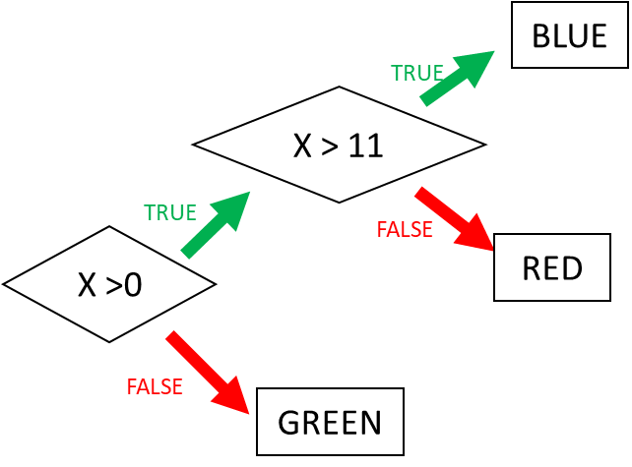

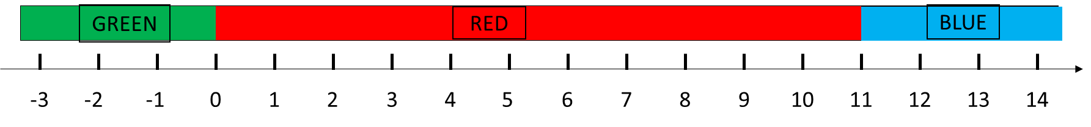

Ex 3: Ranges (1)

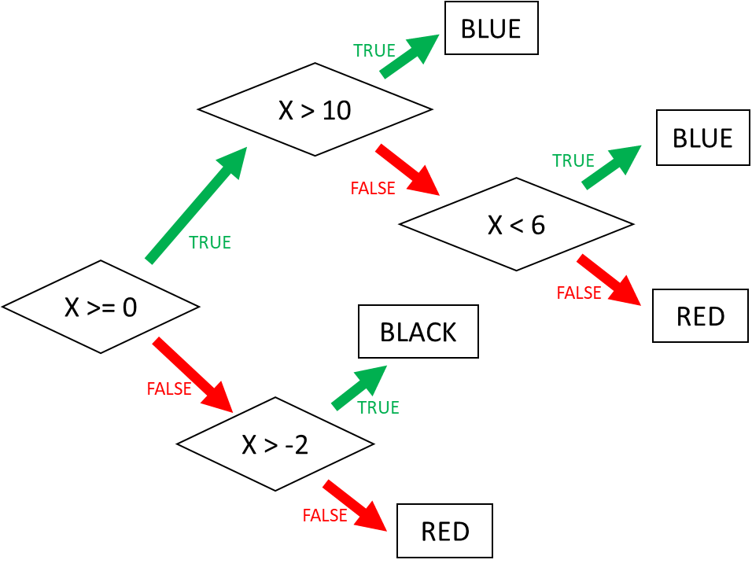

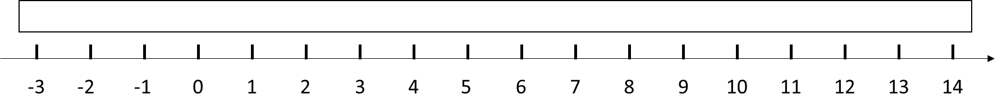

Ex 4: Ranges (2)

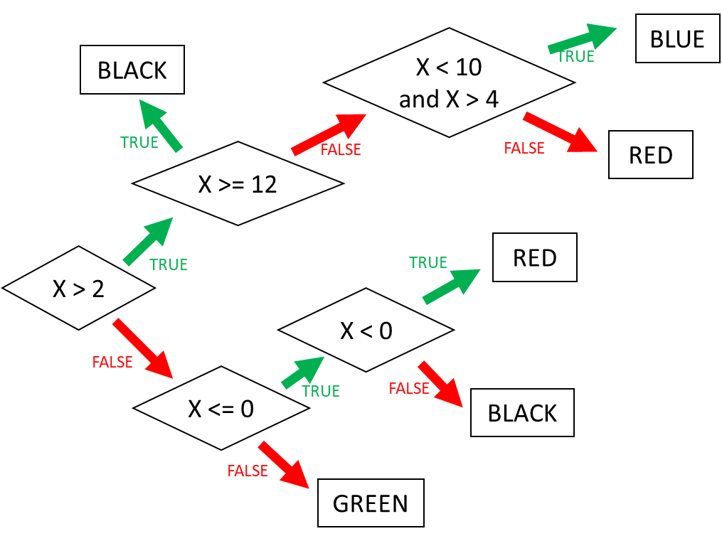



# 2D range colors

Example:

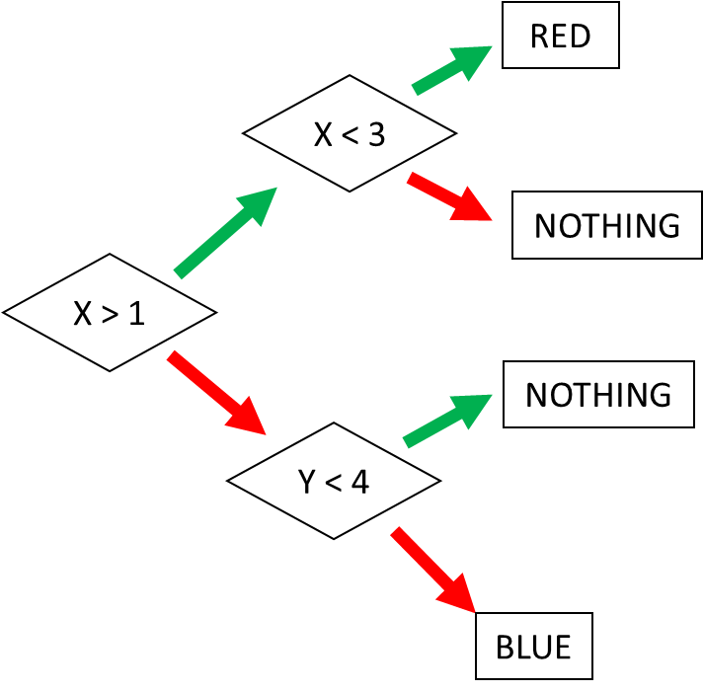 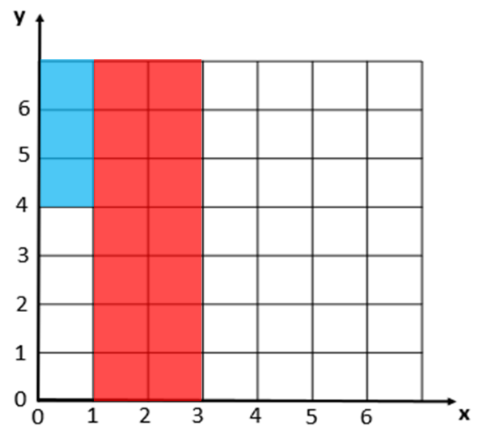

Ex 5: Square (1)

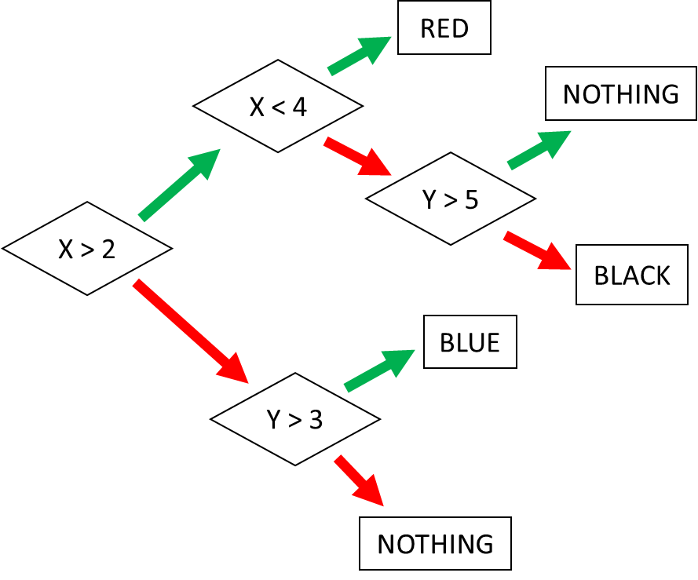 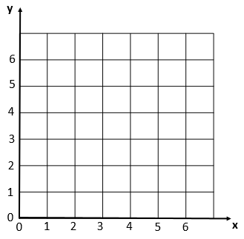

Ex 6: Square (2)

